**Lecture 1:** Git Intro

VCS: Version Control System is like keep tracking of all changes to code.

For example, if we write some code like

**File:1**

1. **Created file-1**
2. **Write some code:**
3. **Int x=12;**
4. **Int b=x+1;**
5. **After that, next time we require some change in the value of x let suppose we wang to make it 12 so we’ll do some changes like  
   (i) int x=~~12~~ 13;  
   (ii) int b=x+1**
6. **Now we want to keep track of change we just did in the code. Therefore, we require a *version control system.***
7. **Best way to keep track of all changes is to make an account on GitHub.**

**CODE SYNCHRONIZING BETWEEN DIFFERENT GROUPS:**

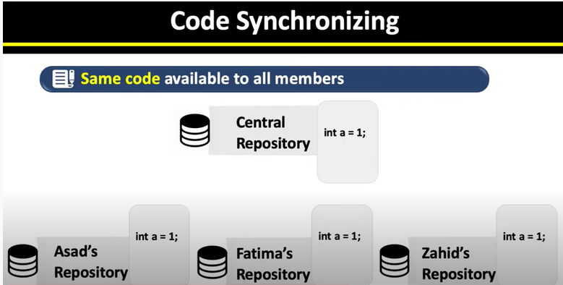

As you can see above there are three group members each have their own code.  
Also, we have a central repository.   
In VCS, we put all our code’s int this central repository so that everyone will have the same updated version of the same code.

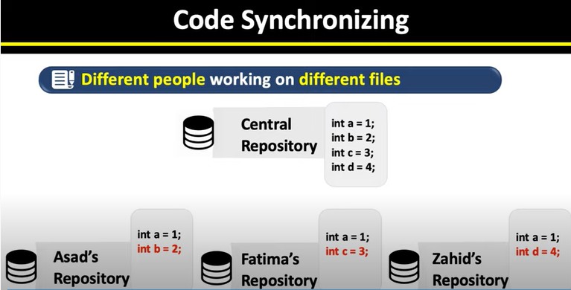

**As we can see, here we have all the updated code in out central repository.**

**Now everyone will have the same code/updated code in their systems.**

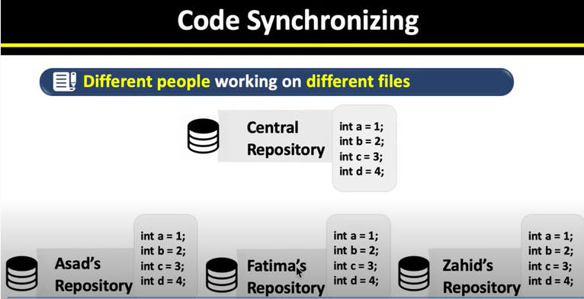

**Everyone now have the same code/updated code in their own systems.**

**TEST CHANGES WITHOUT LOSING ORIGINAL**

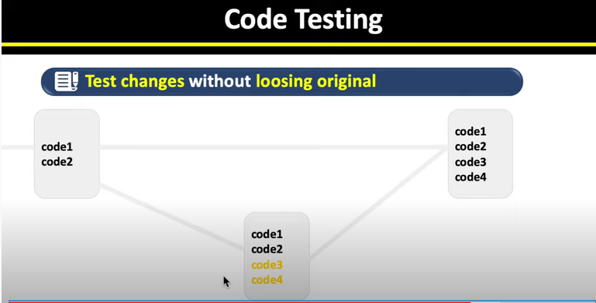

**Until we are not sure about the new added code, we can keep our previous code.  
After that, when we have tested our new code, we can add it to the original as shown in above figure.**

**REVERT BACK TO OLD VERSIONS FACILITY:**

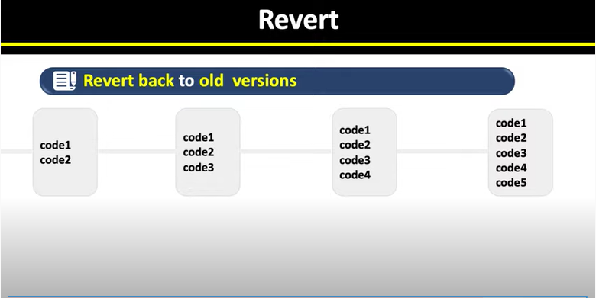

**We can also look back at our code or code history and can find revisions, upgradations, deletion etc easily.**

**CREATING ACCOUNT ON GitHub.com**



From there select ***sign up for GitHub.***

You’ll find a new page like this. 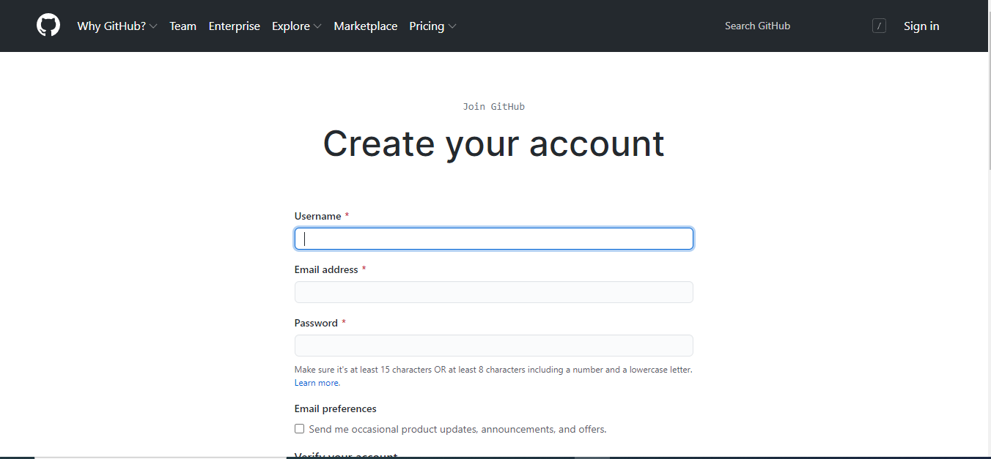

Fill out all necessary fields with respective data and Select **Create Account** button.

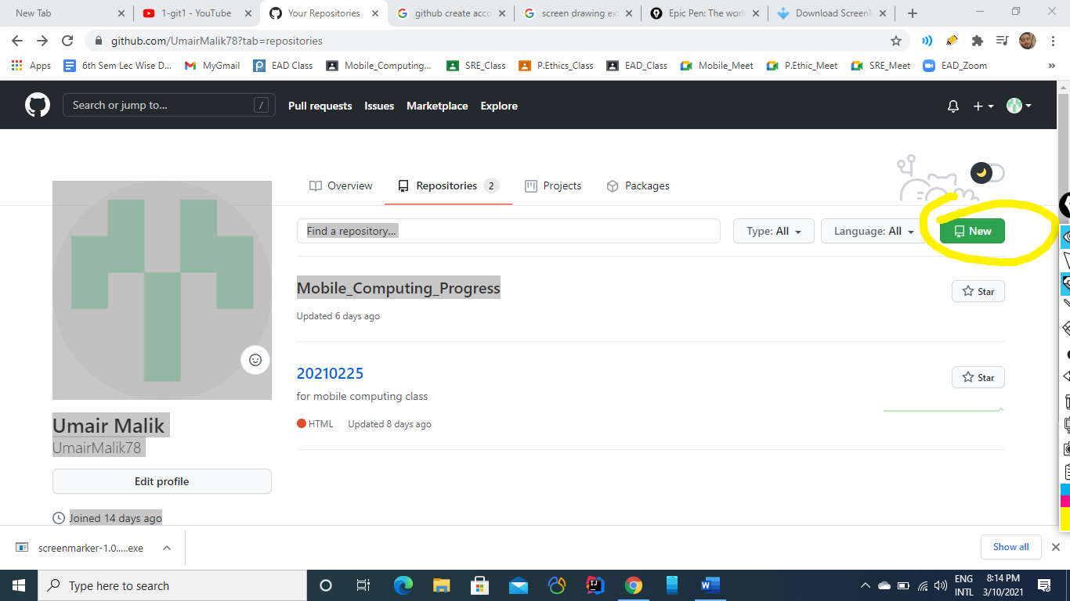

From this screen creeate on **new button**  to create a new Repository.

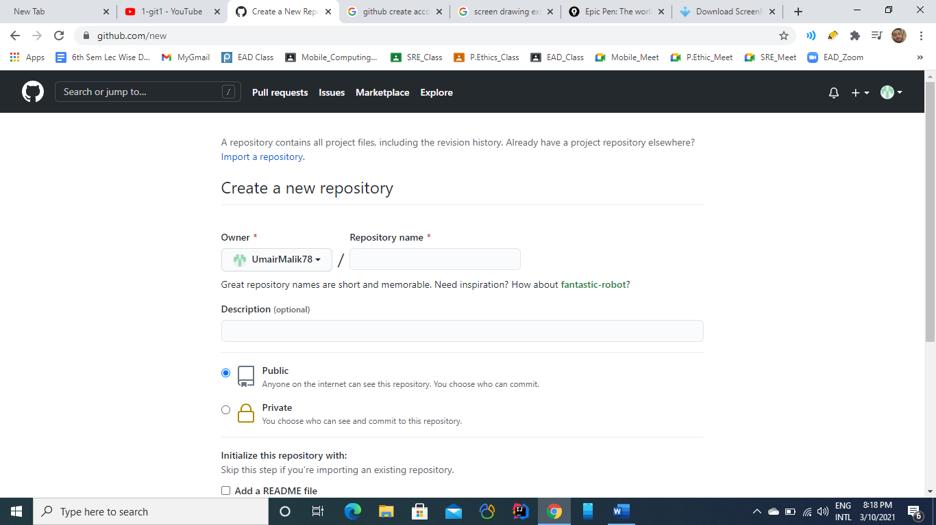

From this menu, Wrtie a new Repository name which weill be of couurse unique wuth reference to you id.

You can also make your repositry as ***Private*** or ***Public***:

**Private**: If you make private, then noone elese can make change to it

**Public:** In this case, everone will be able to see and make changes to your work.

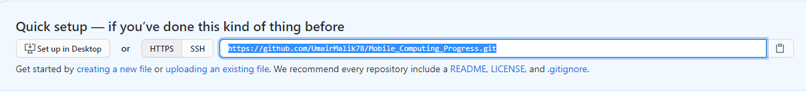

This is the URL of your new Repository, which we’ll use ;ater to work with it.

**Lecture No 2**

**Git Clone:**

1. Git Clone means to cone the central repository into our ocal repositroy
2. For this we use command  
   ***git clone [url]***

Where URL is the url of our repository.

1. When we clone a repos, a folder/repos is created at our system locally.

**How to add files to central repository:**

1. **Place file into the local repository:**
2. Create File into the local repository we created with the help of ***git clone.***
3. Let suppose we create a file named as **Mobile_Computing_Progress.docs**
4. **git add *filename***(i) Add file in the local repository.  
   (ii) git add **Mobile_Computing_Progress.docs**
5. **git commit**  
   (i) It is used to make changes with message to track changes.  
   (ii) git commit -m “First Commit”
6. **git Push**  
   (i) It is used to finally add your work on the server.  
   (ii) git Push

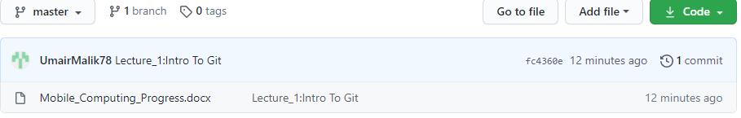

After above steps, we’ll see our file located on the server of GitHub.com

Suppose we want to make changes to file.

1. We first add new changes onto the file
2. After that we’ll add file again using ***git add filename.***
3. Then we’ll make commit.
4. At the end we’ll run push command to make newly file available on the server.

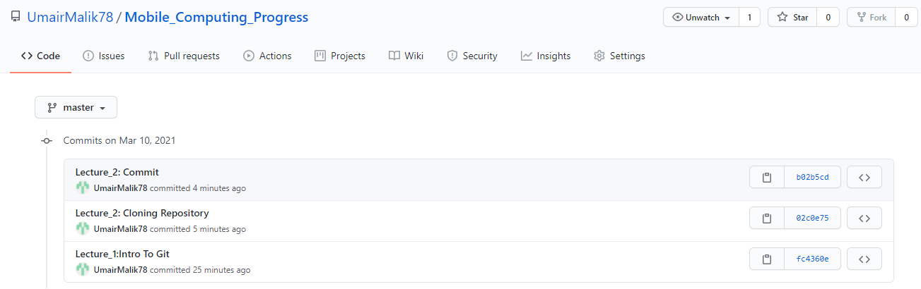

As we can see new commit has been added to the server.

To see changes made online we’ll use

**Git Pull:**

This command is used to get changes from GitHub to our local repository.

**Lecture No 3**

**Merge Conflicts:**

Merge conflict occur when we try to update or change the same line of code at two different points i.e., locallay as well as on main repo.  
Git become confused that which should be save and which should not

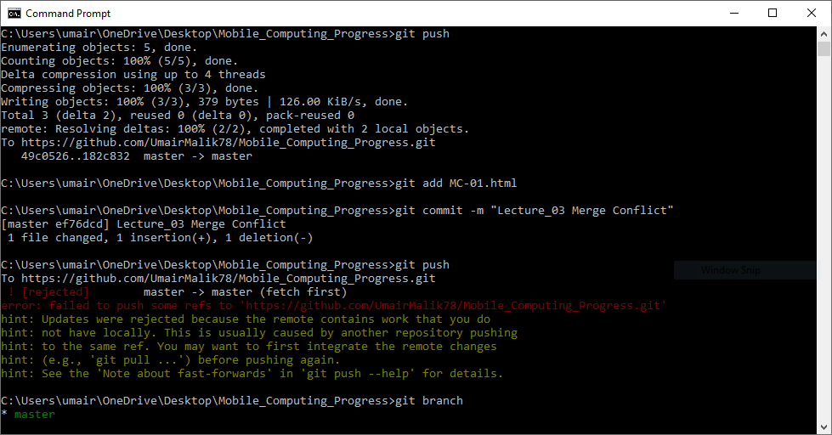

When we try to push our code to main repo it gives us error to first pull the changes made at web  
So we try to pull them first.  
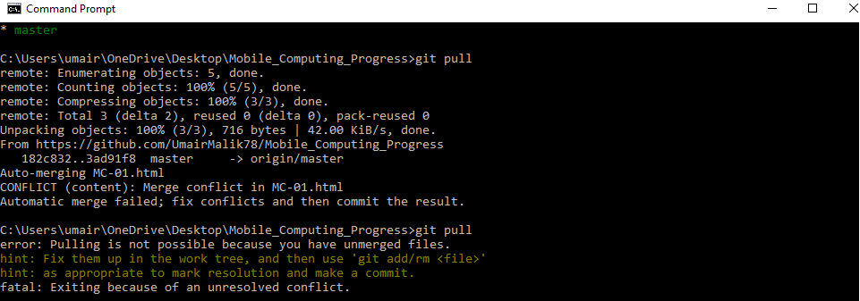

On Pulling, we get CONFILCT ERROR.

**Because same line changed locally is changed at web so we have to make choice which we want to retain.**

Suppose we want to retain changes made at web so we select that incoming changes.

Now when we try to push our code, it will be successfully pushed into the Main Repo or Server.

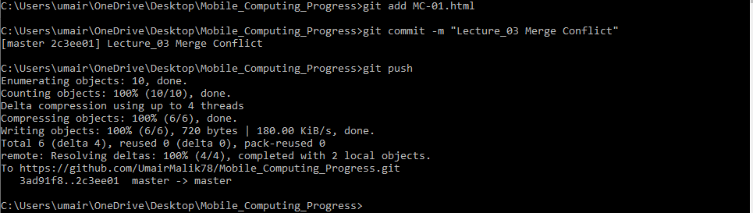

**So in this way, we get the conflict resolved.**

**Git Log:**

Git Log is used to get the details of commits we make in our repository so far.

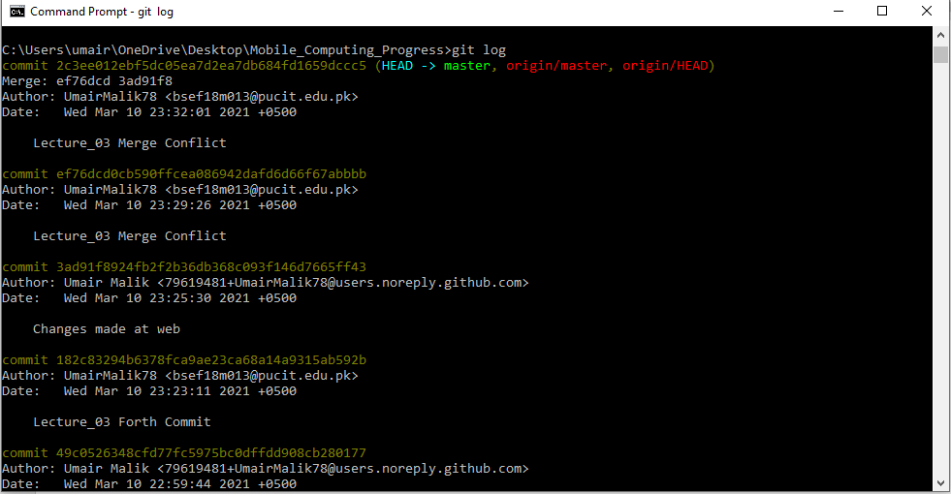

**Lecture No 4: Branching**

**1. REMOVING FILES USING GIT:**

1. First we’ll add teo new text files into our repository using add commit and push method.

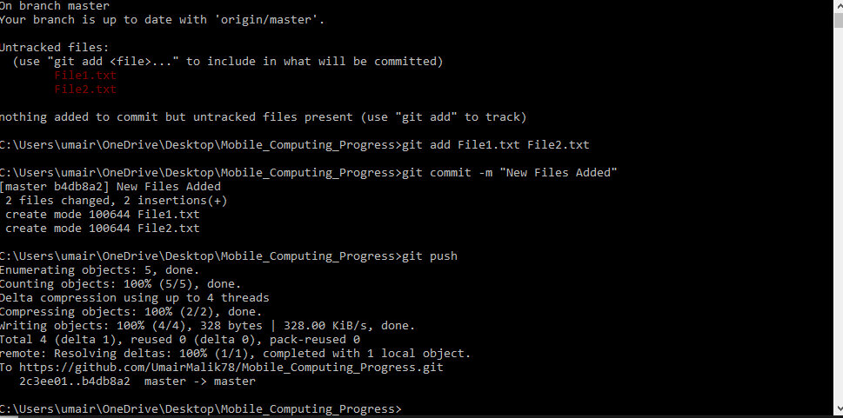

1. Now this will be available on server also as you can see.

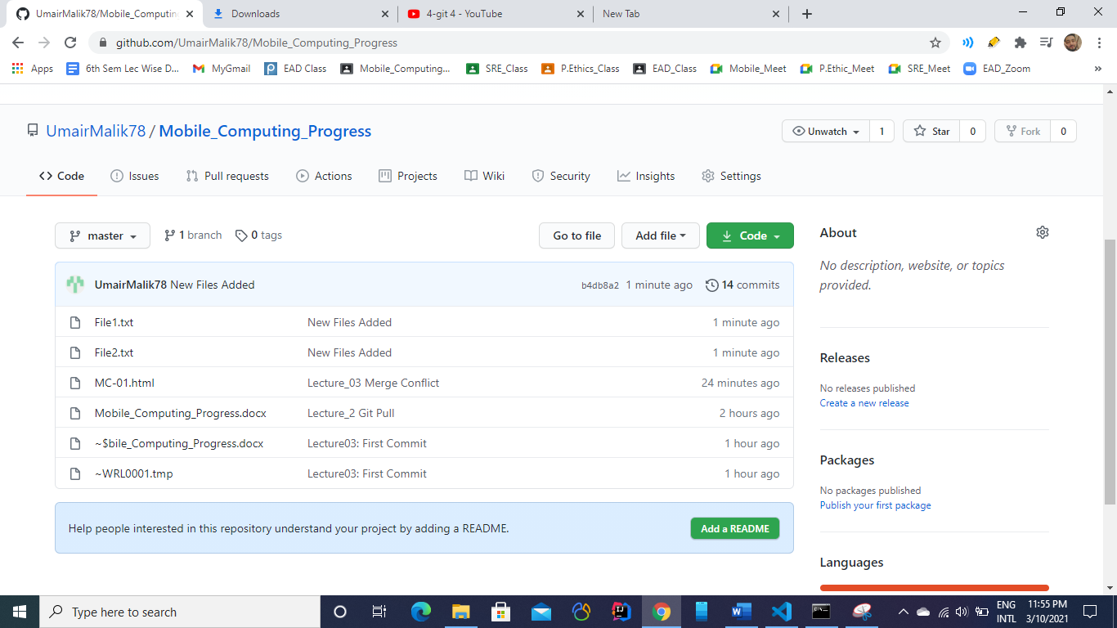

1. Now we’ll delete file 2 using git
2. First we’ll remove file from our local repo.

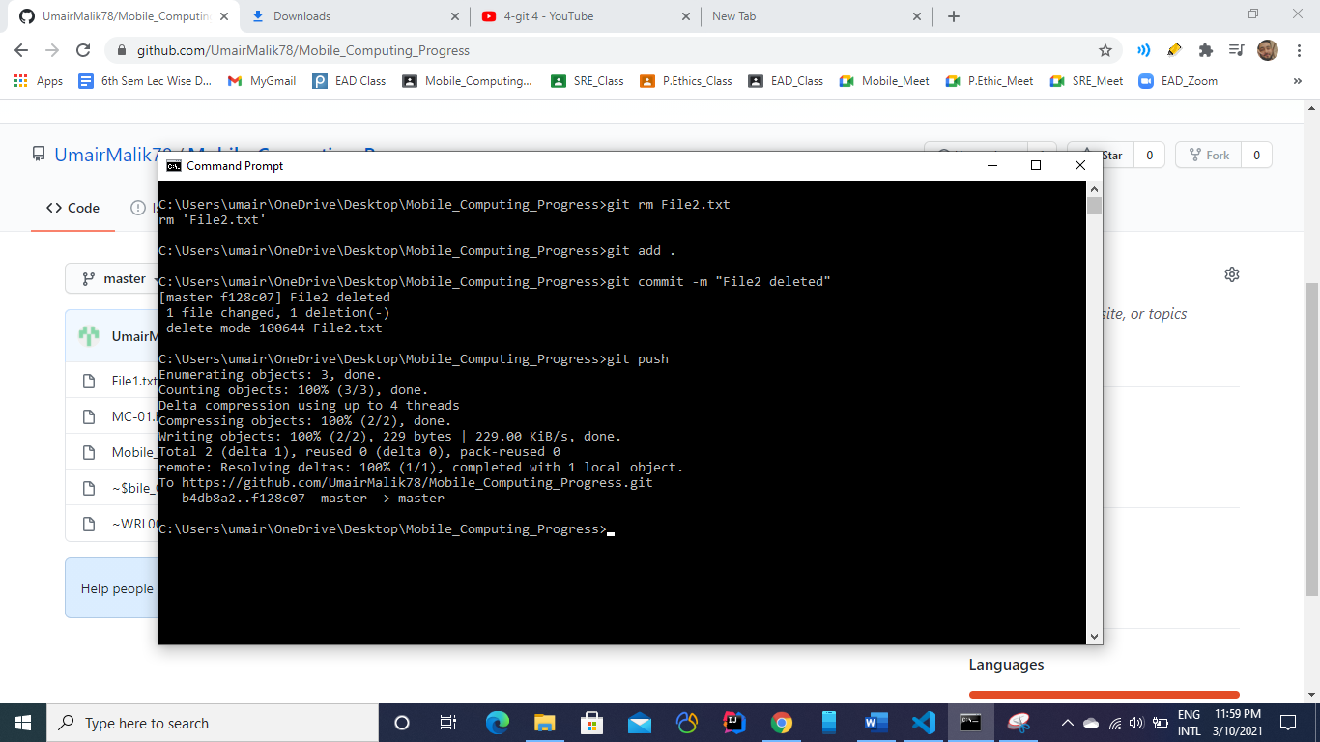

1. Now we’ll see changes at the server.

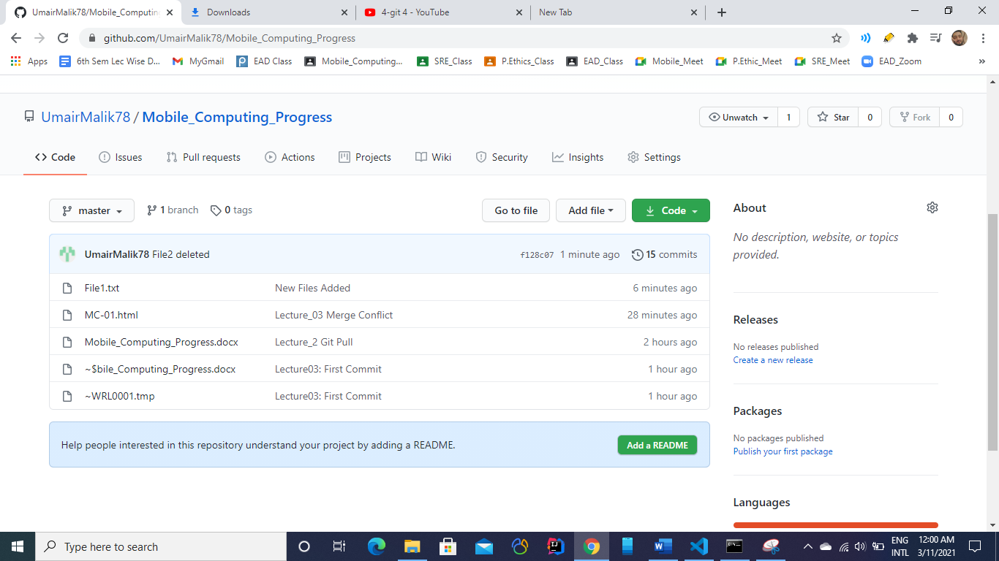

As we can see file 2 has been removed successfully.

**2. BRANCHING:**

**Different comands for branching:**

1. **Git branch**
2. **Git check**
3. **Git merge**

**Create a Branch:**

1. New branch is made with the following command  
   git checkout -b *branchName*

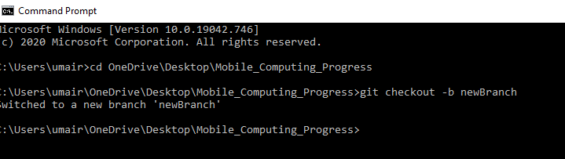

1. Now all of our work is saving in newBranch.
2. As soon as, we switchd to master branch, previous code will be appear,i.e., code we write in the previous branch.

Suppose we are on ***NewBranch*** and we write some piece of code in MC-01.html

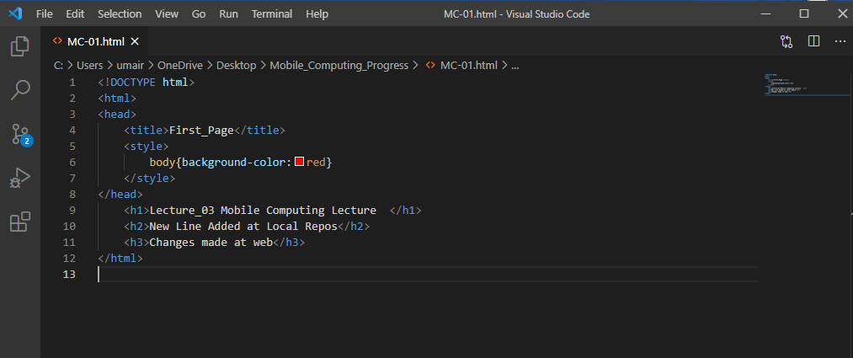

Now we switched to the Master branch:

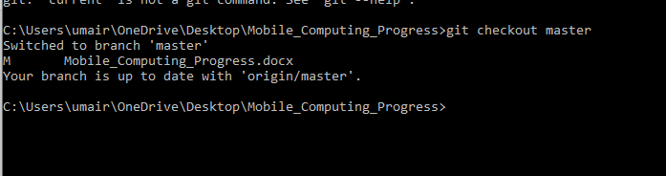

As soon as we shift to it, previous code will be shown in IDE.

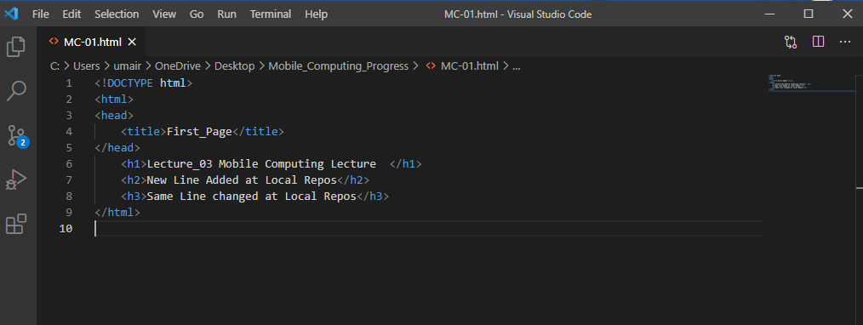

After when we have tested our new additon/new code then we can merge them both with the help of following command  
 ***git merge branchName***

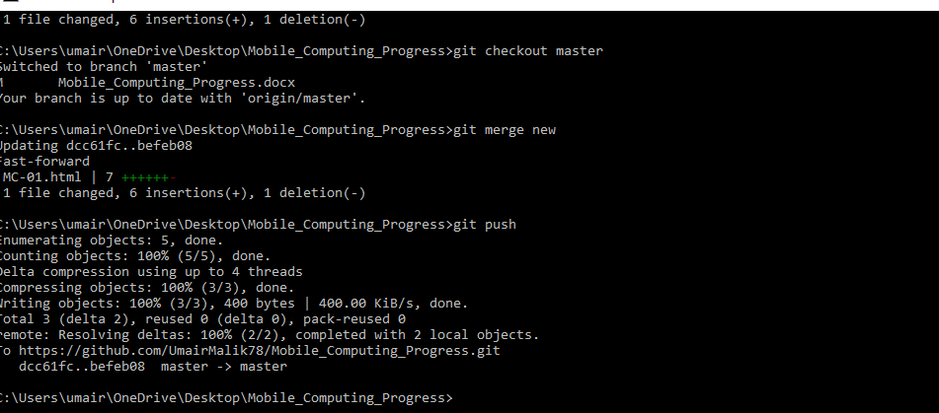

When we have merged our newBranch code with master, then we have no futher need it so we’ll delete it

***DELETING BRANCH:***

To delete a branch simply type:

***git branch -D “branchName”***

**Lecture No 5: Android Studio**

**First Program: Hellow Worlld!!**

1. Open Android Studio on your laptop

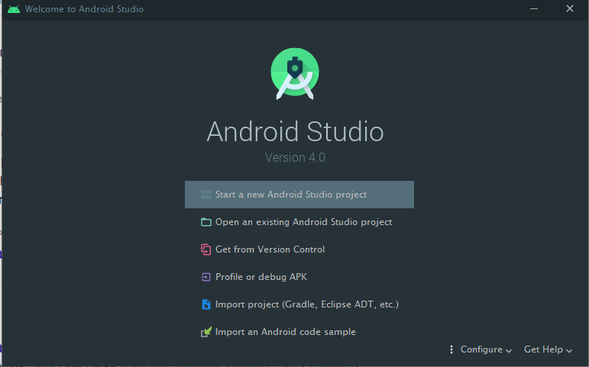

1. Select Start a new Android Studio Project and choose Empty Activity.

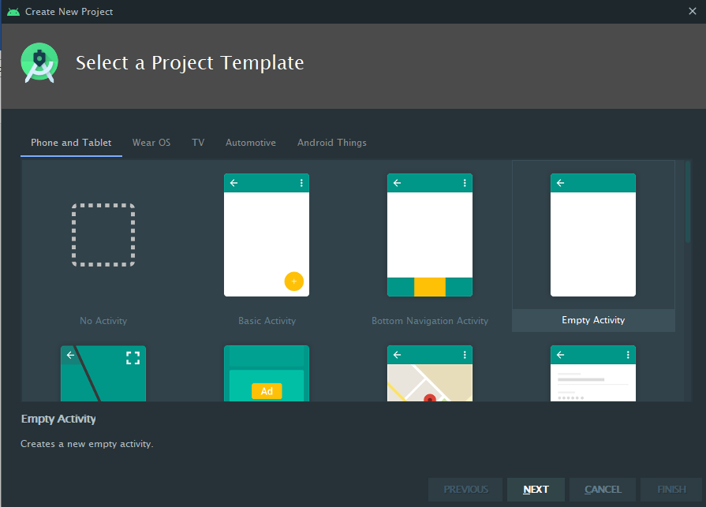

1. Fill the required fields.

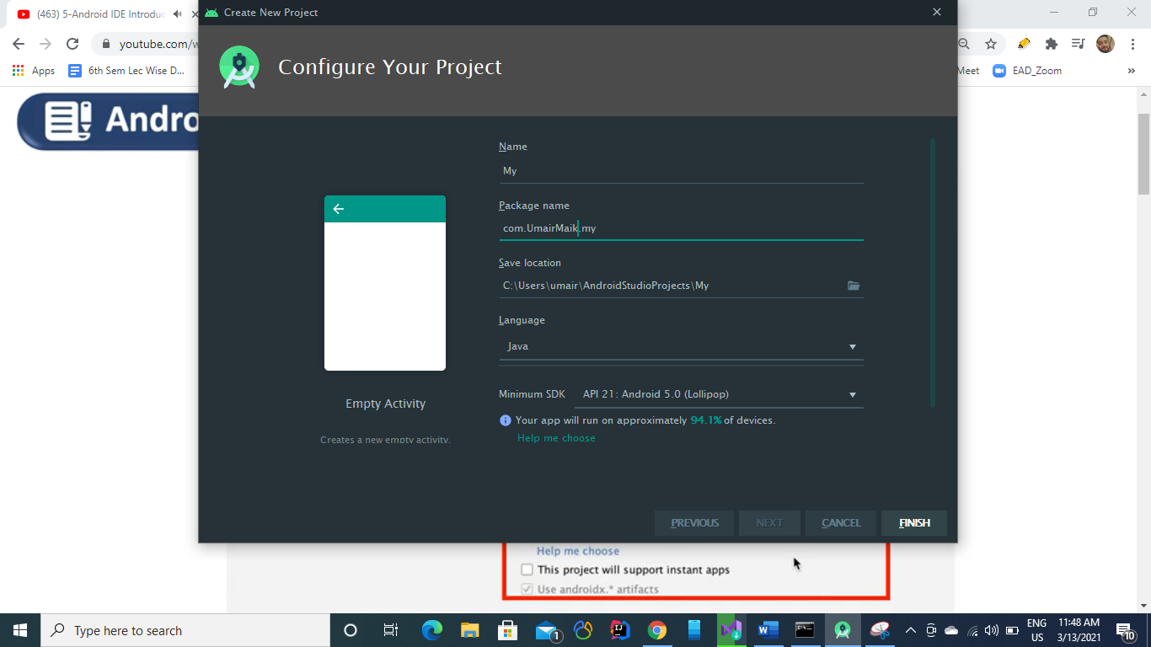

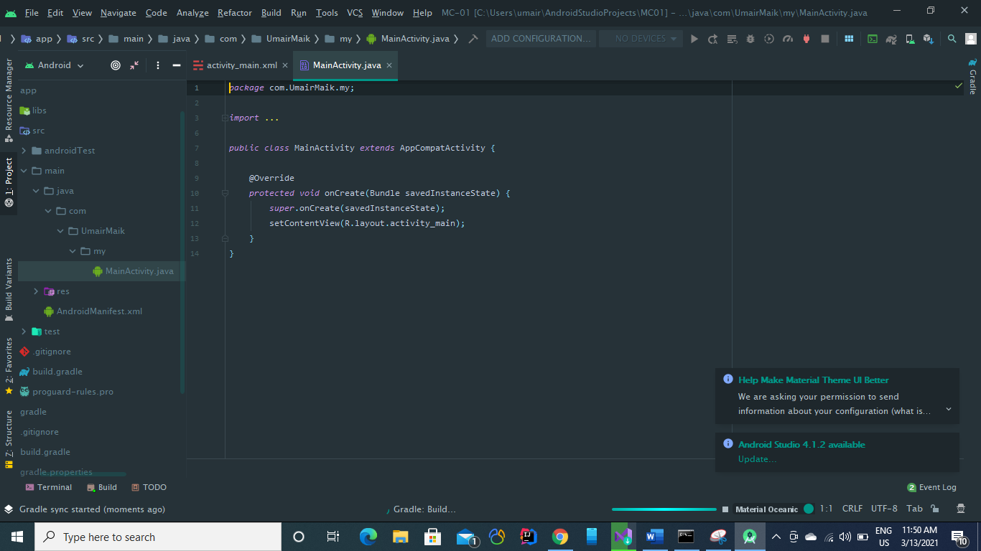

You have two tabs

**Main Activity:** All code will be paste here including variabes logics functions.

**Activity_main.xml:**

It is for GUI.   
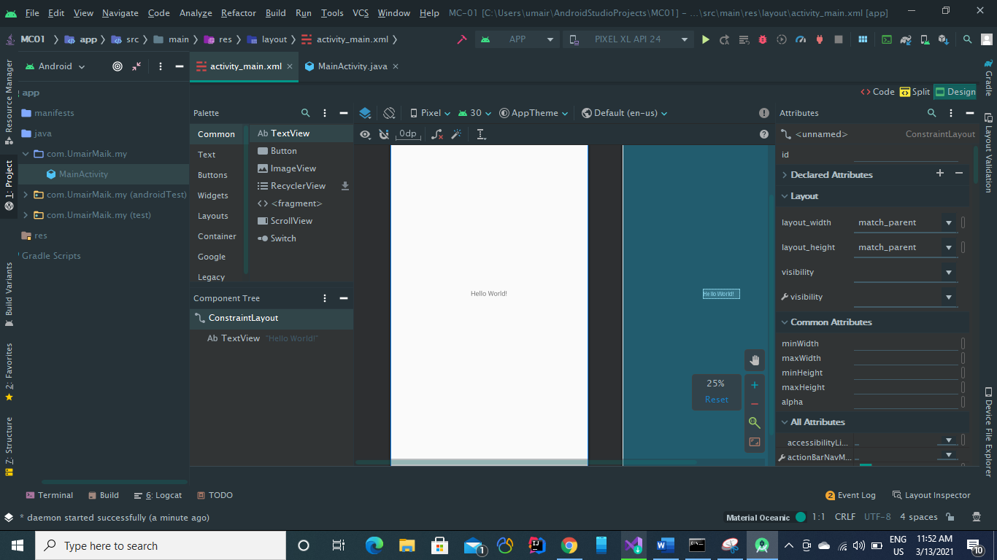

From activity_main.xml we can add buttons, text fields inpiut fields or different GUI options in our application

1. Adjust margins
2. Apply constrains etc

**Writing Hello World in our first app:**

1. Select textview option from Pallete tab and drag a textView into the white screen available in activity_main.xml

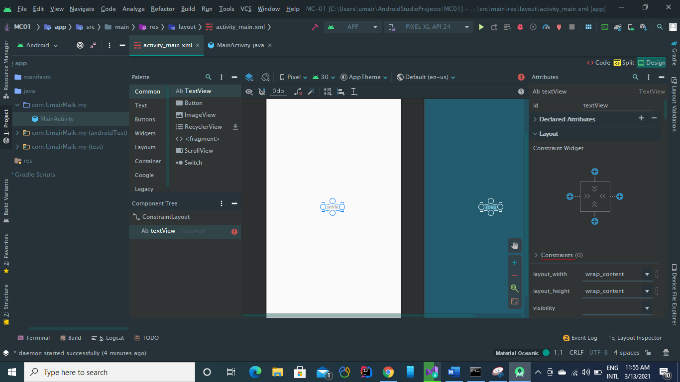

1. TO add text “Hello World!!!” see at right window and under Common Attribute set new text.

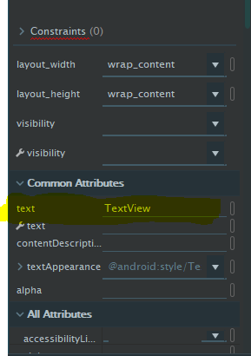

Text will be now shown in white scrren text box  
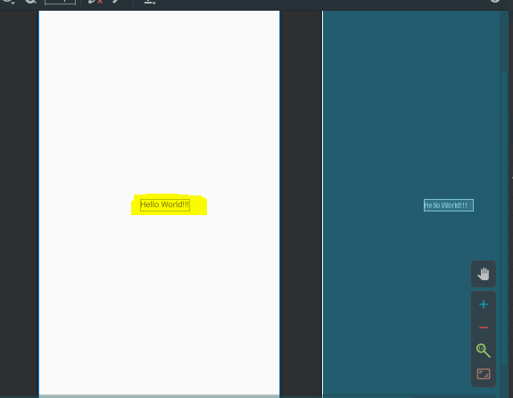

1. To see thr above scrren or to run the app , select your android virtual device first and then select click on Run.

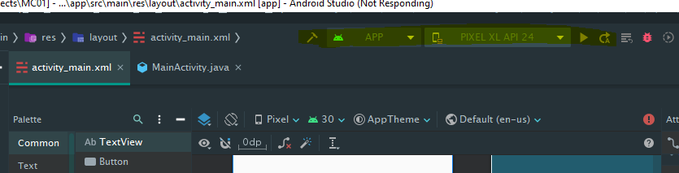

**ANDROID VIRTUAL DEVICES**

1. You can download your android virtual devices from from ***AVD Manager***. Under **Tool>>AVD Manager**.

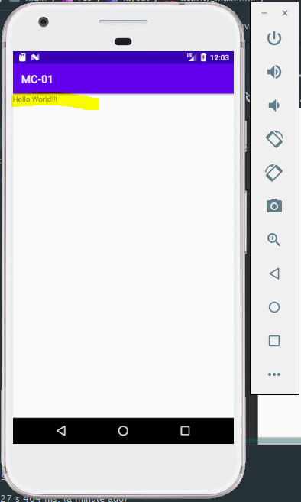

So this is our first Hellow Workd Application

* We can also set
* contraints
* positions
* text color
* text size etc  
  **From Blue print screenand Attributes tab.**

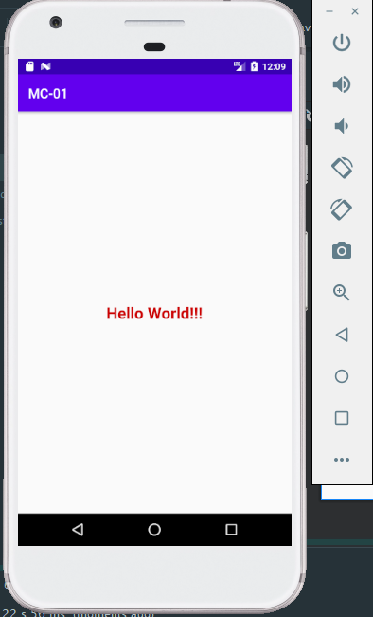

After some formatting.

**Resource>>Values**

In this folder, we define values globally to use in the entire project.

You can manipulate from both options

Either in the text view as well as in the design view.

**For example, we can first anipulate text using deign view:**

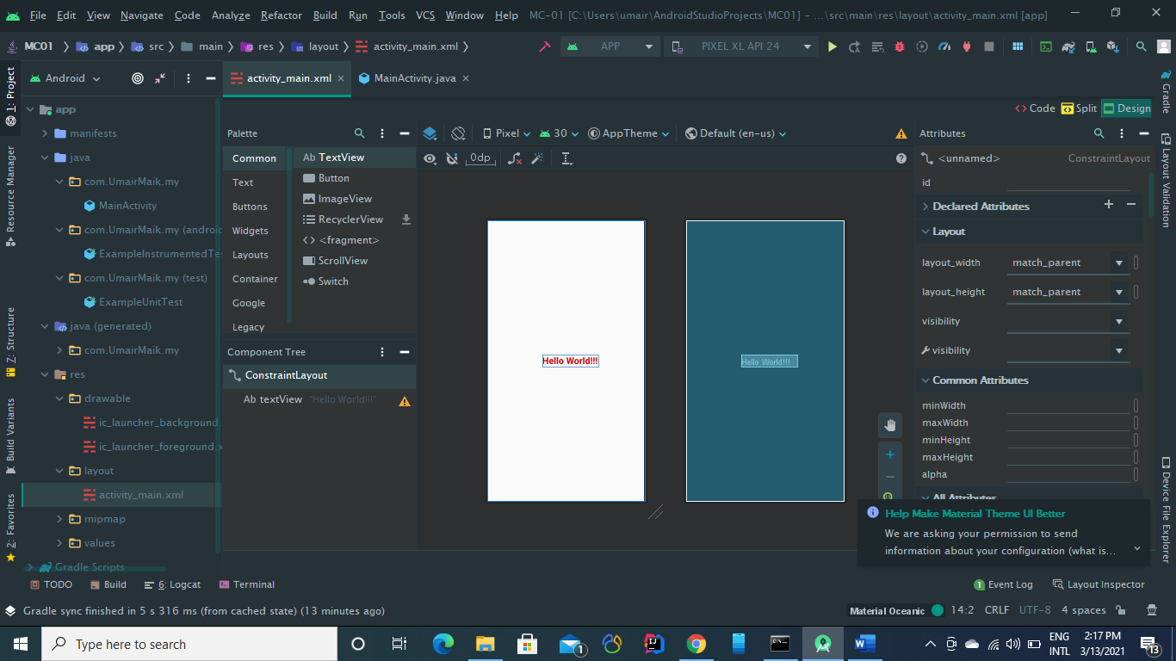

**Changes we made in the design view will also appear in the code view/text view as you can see below**

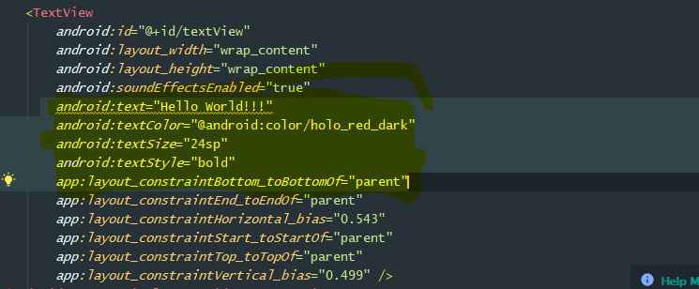

We can set constraints using the design window by just with use of mouse drage options.

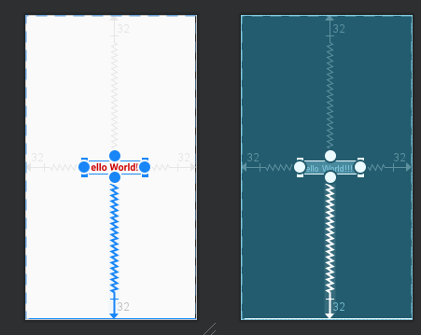

We can also set margins to the boxes or options from the right side of design window.

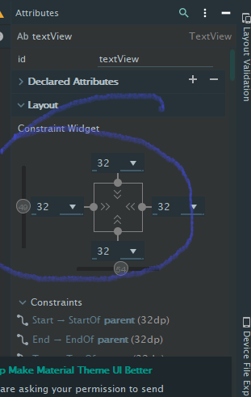

**Different Screens Using Android Studio Development**

**Screen 1:**

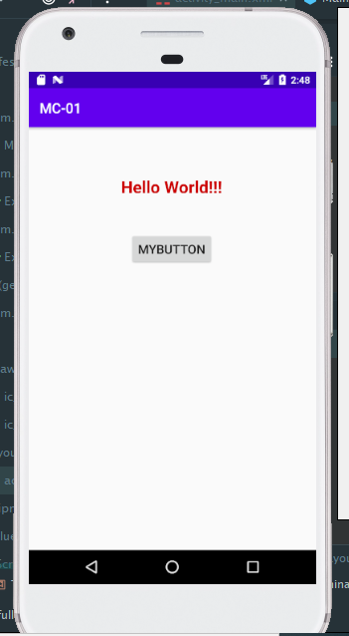

**Screen 2:**

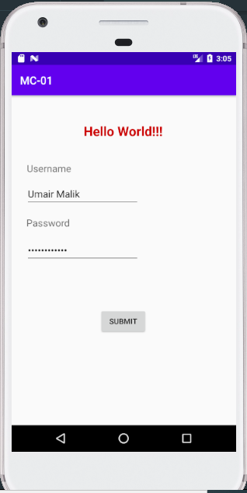

**Screen 3:**

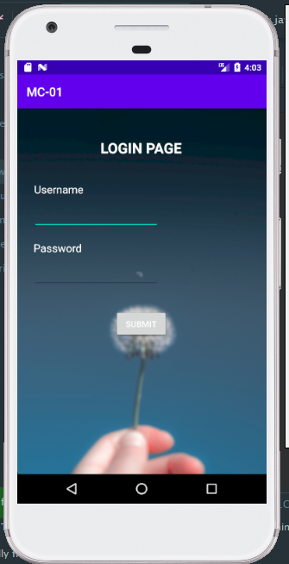

**Lecture_05 Layouts in Android Studio**

**What is View?**

A view is anything on the screen through whcich user can intercat with and can see. It is usually called as “***Widgets”.***

**What is ViewGroup?**

A viewGroup is like a container which contains different views in it. It is ususally called as “***Layouts***”. 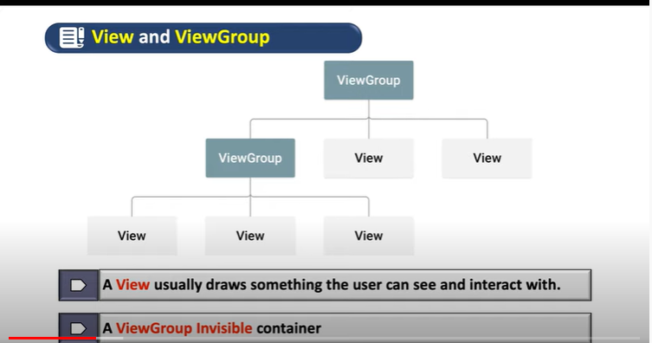

**Adding New Linear Layout:**

1. Go to res>>Layout folder
2. Right click on folder and select add new layout Resource File.
3. A new window will appear lke this
4. 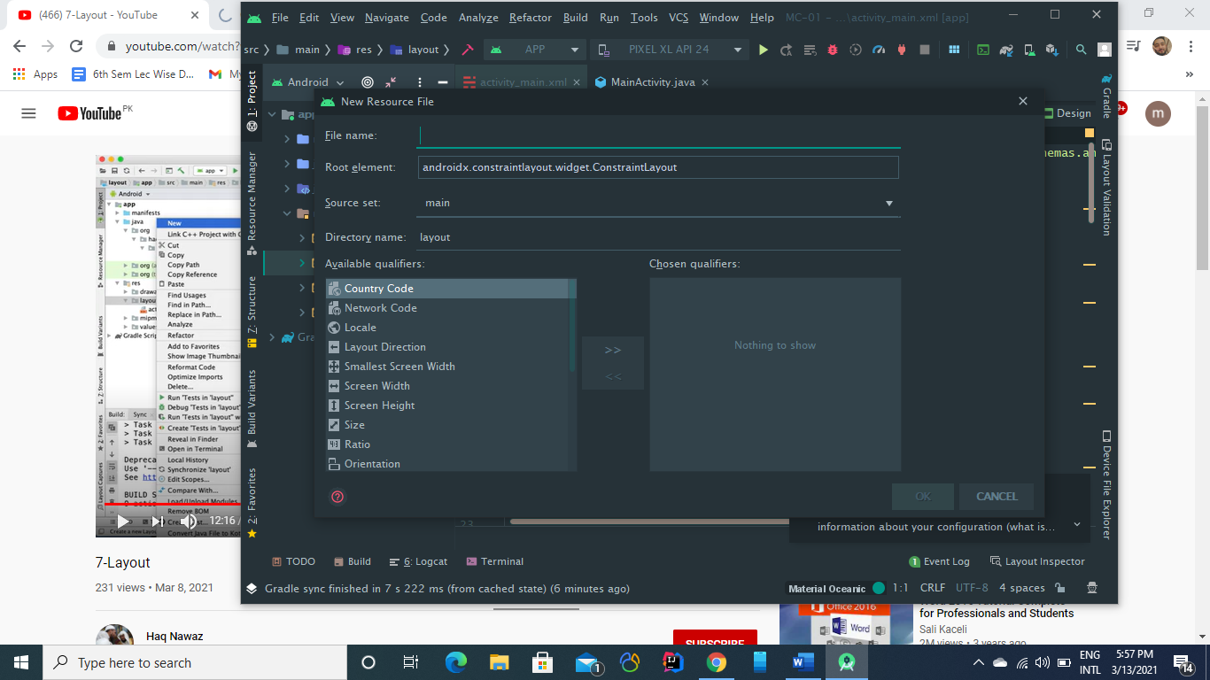

Now we’ll add some widgets like a button and a text view in the layout.

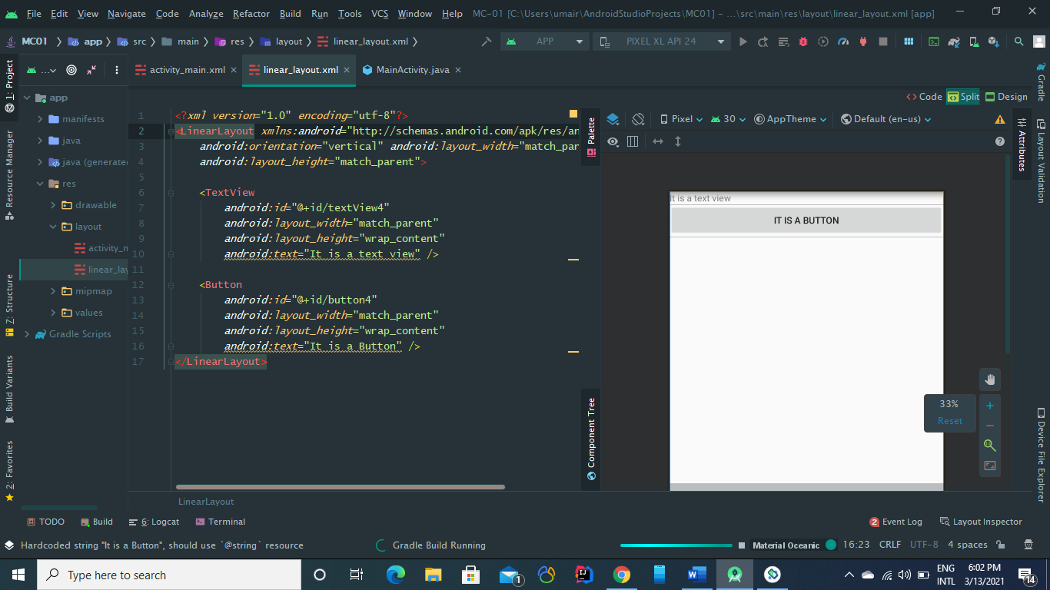

We also have to load the layout in the main_activity.java which tells the compiler from where it should start.

By default, It is set to ***activity_main.xml.***

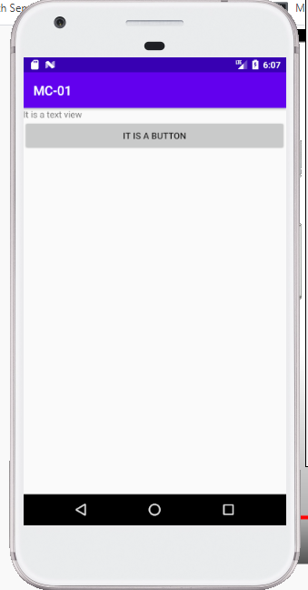

As we cann se, in this layout all elements come in sequential order or in linear form.

**Constraint Layout:**

Suppose we want to add a textview and a button and want them to align then we’ll use our contraint view in this regard.

Some Contraint Layout applied in the image below

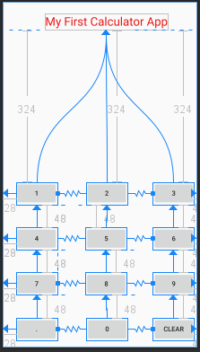

Result of above contraints is shown here:

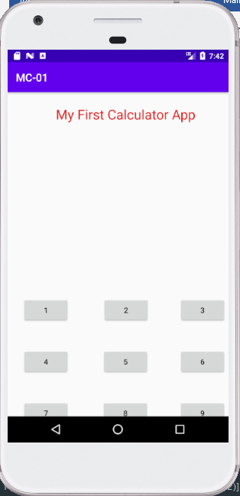

We can also use chains

Chains are used in constraints to make the distance from one view to another fixed.  
In chains Biasness doesn’t work as you can see in the image below.

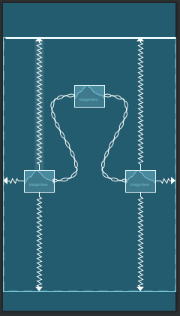

No matter in which orientation we go, the distance from right and left view, will remain same.

***Lecture No 6: Activities and Intents.***

***Activity:***

Every screen we see on our android app is like an activity. It is an application component represents a indow or one hierarchy of views.

Typically fills the screen, nut also can be embedded in other screens as well.  
**Example:**

1. Opening a dialer
2. Opening Camera
3. Opening Search bar etc.

***Intent:***

An intent is like a request or description of a request we make via *android system.* We request tht we want to perform some action.

**Example:**

1. Intent an activity
2. Calling facility
3. Main activity start Surah Recitation Activity

Now, We’ll build an app with 2 activities , and will also initiate some intents.

So Here we go!!!!!!

1. Create an Empty Project as always 😊
2. Write down all necessary fields and click finish.
3. After that create a screen using views and add some constraints as well.  
   Adding Images in Background
4. Now pick some cool background image if You want.(Don’t know how to add image in the background? Don’t Worry, I also learned today :D .
   1. **Download image you want**
   2. **Check the resolution of image according to your device**
   3. **Put the correct image in res>>drawable>> folder**
   4. **Add the image in your activity.xml file code view such as** 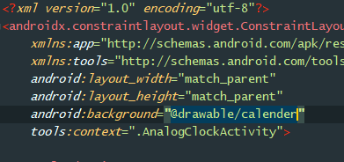
   5. **Mine was named as “*Calender*”**
   6. **You are all set.**

**To add a new activity Follow the method below:**

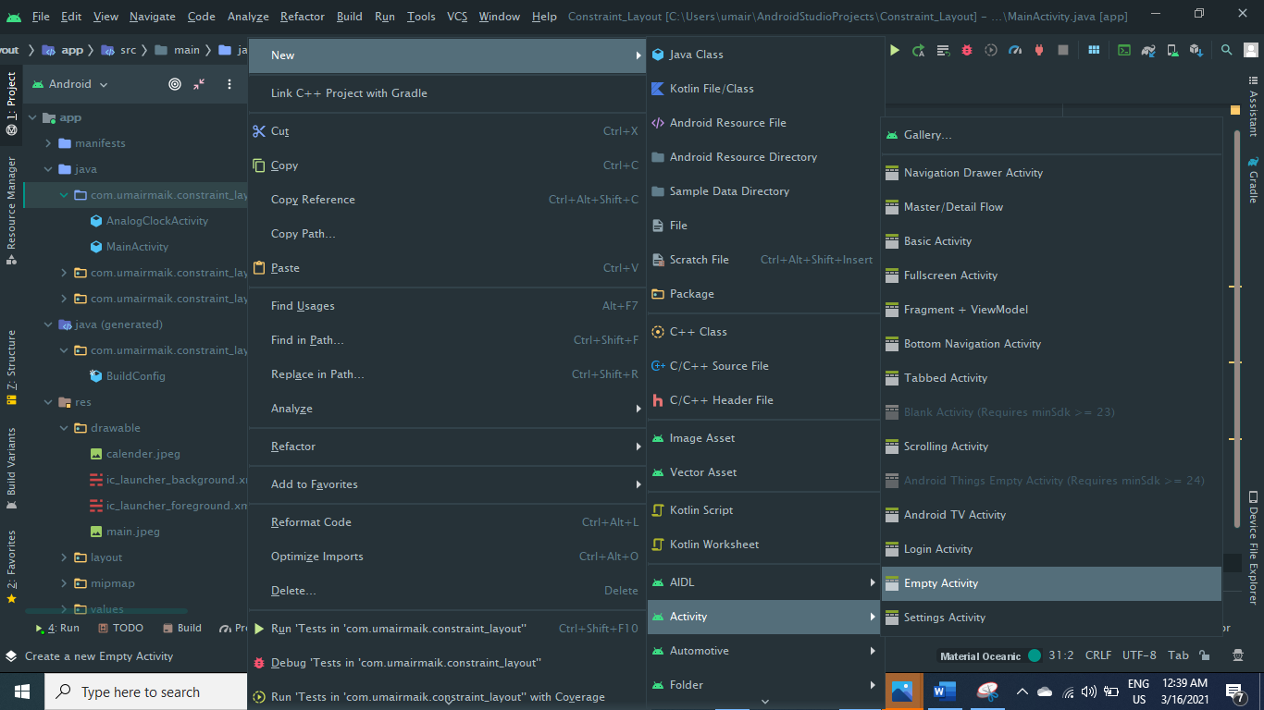

It will create a new activity i.e., **a .java and .xml file(if you want).**

Now design both activites as you want first.

**How to add Intents?**

Intents are used to cal some system events i.e., they are usually some requests to system(android system) to perfomr some actions

For example, if you want to ask system to open a website for you,You may add the intent like this(**in your mainActivity.java**).

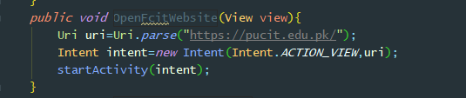

Intents are usually called on some events  
For example on a click event of a button. So

1. Create a button in ***activity.xml*** file.
2. Add OnClick event litsener to it using this.  
   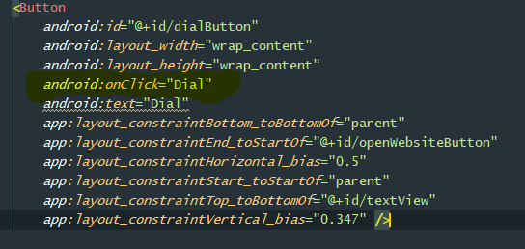
3. Now add the same name method (mentioned above) in your MainActivity.java

**Outputs:**

|  |  |
| --- | --- |
| **First_activity.xml ( design)** | **Second_Activity.xml (design)** |

**Screenshots of Running App**

|  |  |
| --- | --- |
| **First_Activity** | **Second_Activity** |

**\*\*\*\*\*\*\*\*\*\*\*LECUTRE NO 9:Actvity Life Cycle\*\*\*\*\*\*\*\*\*\*\*\*\*\*\*\*\*\*\*\***

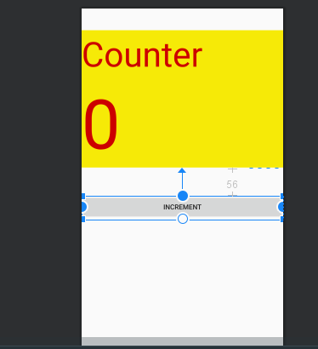

First we create a simple Counter app to understand activity Life Cycle.

So, We created a laayout look like above

We added two **TextViews** and a **Increment Button**

Now, We’ll add an OnCLick Event Litsener on this button to increment the counter Value.

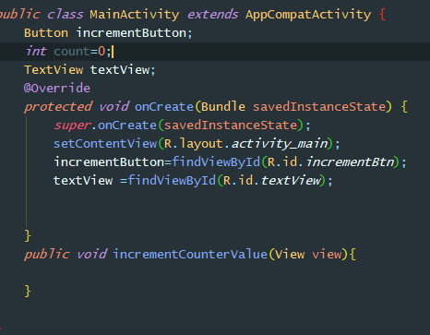

Here on Main Activity, we added button and texrtView attributes plus an event litscener function as ***incrementCounterValue which will be called when button is clicked.***

Also we added a count variable and initialized it to 0 so that we’ll increment it every time incrementButton is clicked.

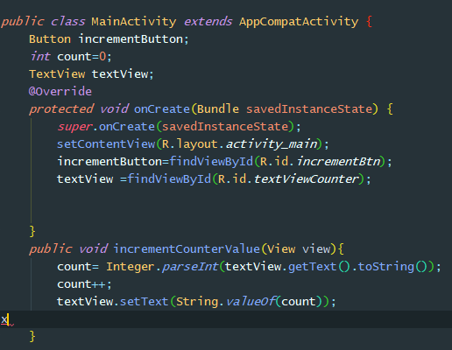

We have added the function and now it is in working position as you can see below

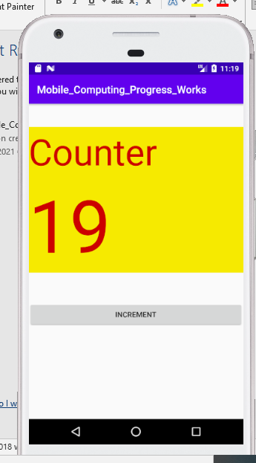

**On Click on *Increment button* valule of counter is incrementing.**

**But Here comes a problem, that when you rotate the screen the valule resets itself i.e., goes to zero again.**

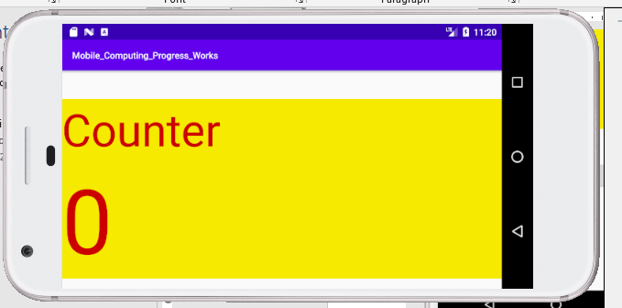

**As you can see above.**

**This is happening because of activity life cycle problem, when the screen is rotated, onDestroy() is called, which deletes all the variables and then again on create() is called which means again application is loaded as first time.**

**Details are listed below.**

**There are 6 Calback fucntions that are called.**

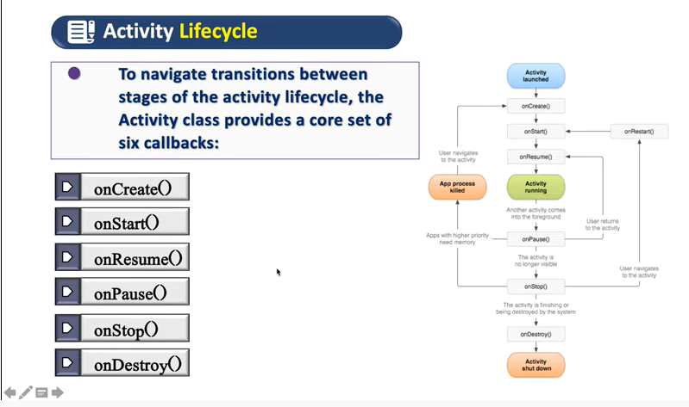

Firstly, when we run app for the first time, following three methods called.

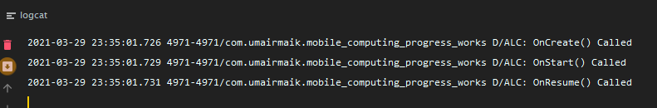

When we rotate the screen following methods triggerred,.

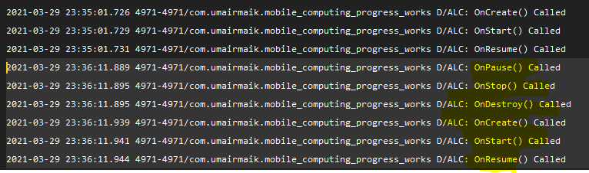

Following highlighted methods called which also include onDestroy() method which destroys all the data we stored at runtime inclluding counter value.

When OnCreate() isi called again all data values set to their initial values i.e., count will be initialized to 0

Now We’ll see thr affect of Activity Life Cycle on moving between activites so for this purpose we are making two new activites as **MainActivity2** and **MainActivity3**

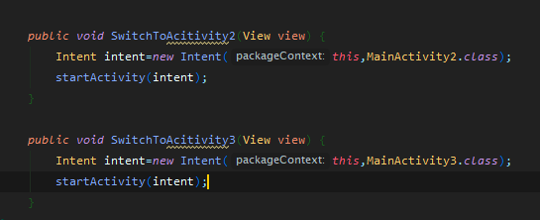

We have created two intents to move between activites.

Now we’ll see the sequence of functions call when we switch between activites.

Currently the logcat shows this

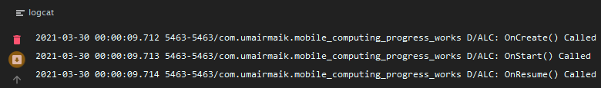

Now, we’ll switch to another activity i.e., MainActivity2

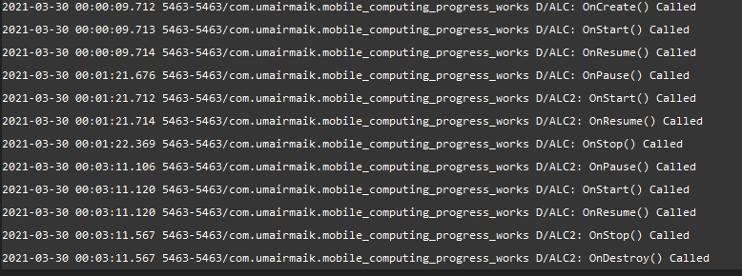

As you can see, when we switch the activity2, onPause() of 1st is called and ONCreate(),OnStart(),onResume() of 2nd called also onStop() of firt is called.

But when we go back to our 1st activity, onStop() ,onDestroy() called of 2nd activity.

**So in this way activity life cycle runs**

Now We come back to our original problem of getting valye resetting whenever we change screen orientatons

**Reason: Because OnDestroy() Method called**

**Solution:**

**We’ll create OnSaveINstance() method override method which will save ouo counterValue whenever right after OnPause() method is called.  
It is like a data storage which saves our states ni key,value format, which we can retrieve whenever we want again.  
We know that each time App starts onCreate() method is called.  
So what we’ll do is to get those saved instance values in OnCreate() method and set the value in the textView.**

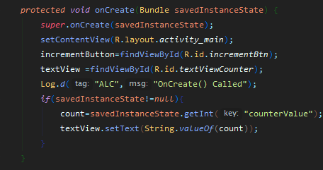

**Like this.**

**#----------------------------------End----------------------------------#**

**\*\*\*\*\*\*\*\*\*\*\*\*\*\*\*\*Lecture No 9_List View\*\*\*\*\*\*\*\*\*\*\***

**Adapters:**

Adapters are used to convert dta format to another.

They are just like normal adapters we use in our daily life such as mobile charging adapters. Similarly, we have android adapters.

**For example**, we want to create a listView in our app which contains some data which may be string,int,float etc.

We’ll create an ArrayList<T> obviously, but to assign values of this ArrayList to our ListView object, we’ll use Adapters.

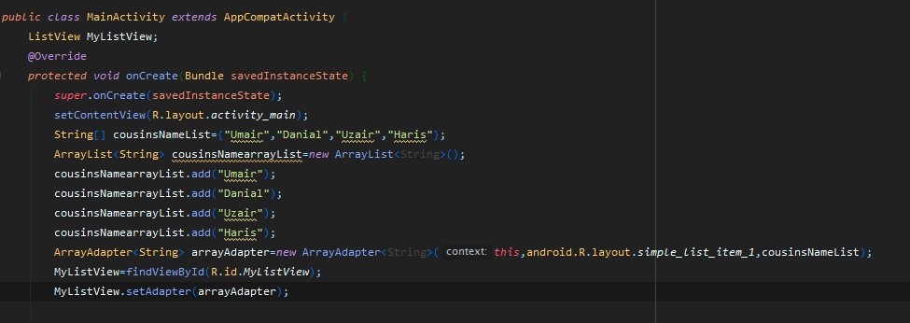

Here we created list of cousin names in two different data structures.

First in simple array and other is ArrayList foam.   
The use of Adapter here is that whatever form we use it will adapt the data according to the object , the adapter is set to.

In this case LisrtView object sets the adapter, so data will be format according to the listView object.

**Output of Above Code is this:**

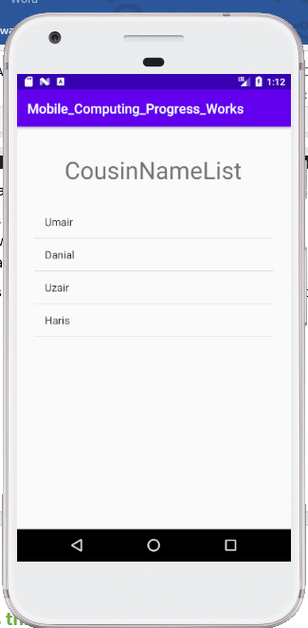

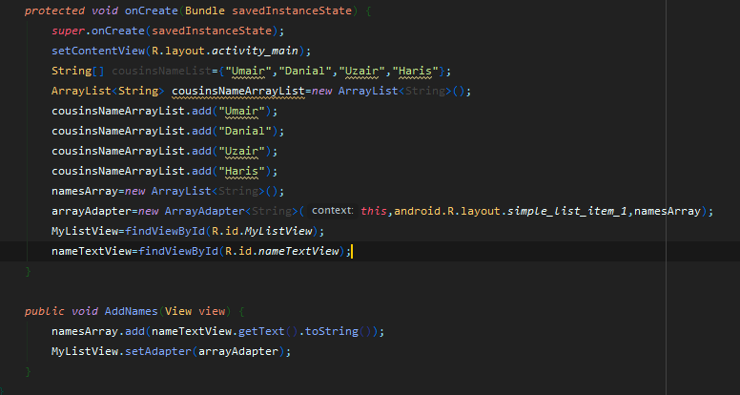**Above code will get input from user and the add the name he/she will add.**

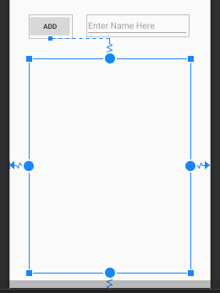

**So, We use adapter here also.**

**We can also sort our data with the help of *Collection.Sort(****array_list****).***

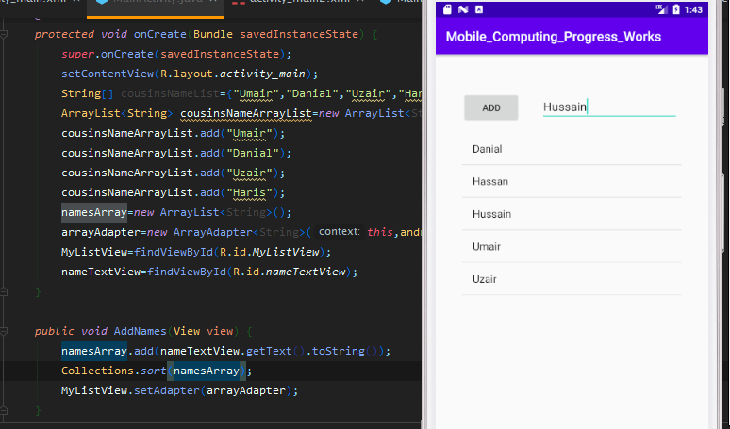

As you can see, by just adding Collections.sort(nameArray) our data is in sortedfoam now.

**\*\*\*\*\*\*\*\*\*\*\*\*Lecture No 10_ArrayList\*\*\*\*\*\*\*\*\*\*\*\***

Now, we’ll write click litsener on list items.  
First of all we write the code to set onClick litsener.  
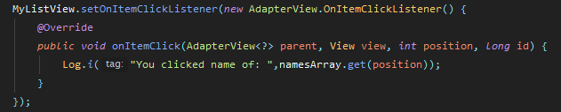

As we can see in the logCat :  
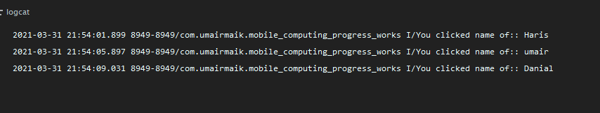

It shows on which list item we clicked the mouse.

**Now we’ll Implement Table based on number/value of Seekbar.**

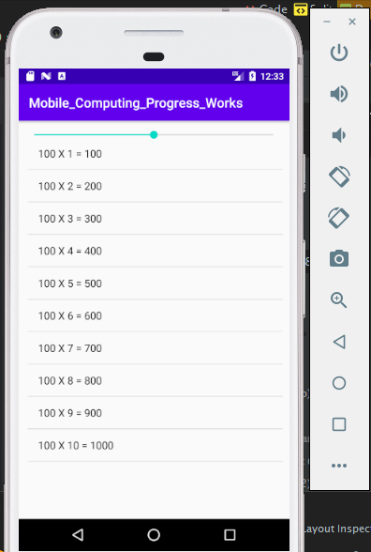

**On the basis of value of the seekbar, table is generated.**

1. First we crete a seekbar
2. Then we create a ListView
3. Then we create a ArrayAdapter
4. Then we create an ArrayList
5. Then we get these elements in MainActivity

Then we write method   
mySeekBar.setOnSeekBarChangeListener(*new* SeekBar.OnSeekBarChangeListener()

1. On each chagning of value of seekbar functuon is called and arrayAdapter is notified as we change elements in tableArrayList.

**\*\*\*\*\*\*\*\*\*\*\*\*Lecture 10 SQLITE \*\*\*\*\*\*\*\*\*\*\*\*\*\***

First we’ll create a simple form which takes Name and Age of student as input.  
For this create a plain textBox and then for Age number box.  
Write their hint values in resource file  
***res>>value>>string>>***

Then create a switch as **IsActive.**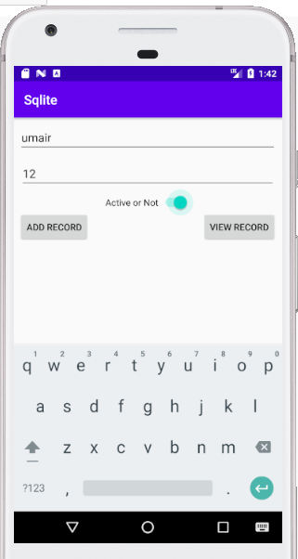

**Design View:**

